Neural RGBD

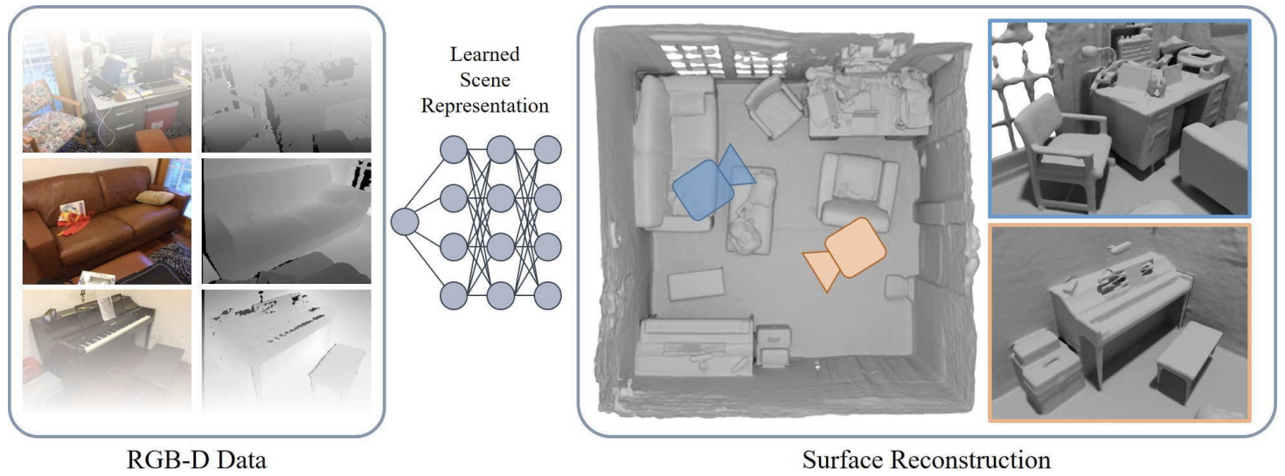

Neural RGBD uses a SDF-modified version of neural radiance field to apply NeRF network in scene reconstruction tasks instead of rendering images synthesis. The input data of this model is a series of RGB-D images along with camera intrinsic and poses of each captured image. Then, the input data are fed in a multilayer perceptron that learns to represent the surfaces implicitly using TSDF. For optimization, a batch of pixels are embedded in the form of rays according to the camera information. Adam optimizer is used to minimize the defined loss function with reference to the network parameter and camera information.

Main Paper

<https://dazinovic.github.io/neural-rgbd-surface-reconstruction/static/pdf/neural_rgbd_surface_reconstruction.pdf>